# Story ID: 23 Staff accounts

**1. Test scenario:** When employee details are edited the change is effective immediately and permanently in the employees details screen.

**Expected outcome:** All relevant information has been updated successfully and is available in the employee details screen.  
**Outcome**: Success

**Selenium Automation Testing file**: Employee_Details_Edit

**Selenium Automation result message:** [info] Test case passed

2. **Test scenario:** Test multiple account types to check they have access to the appropriate features.

**Expected outcome:** Only employees have access to the Utils tool bar, all other user accounts should not even be able to view Utils tool bar.

**Outcome**: Success, passed all tests

**Selenium Automation Testing file**: nouser_access_to_utils

**Selenium Automation result message:** [info] Test case passed

3. **Test scenario**: Attempt to create two employee accounts using the same username.

**Expected outcome:** A username can only be used once to create an employee account.

**Outcome**: Success

**Selenium Automation Testing file**: account_only_created_once

**Selenium Automation result message:** [info] Test case passed

4. **Test scenario**: Use the admin account to create a new employee account and update an existing account.

**Expected outcome:** From the admin account a new employee can be created and edited successfully.

**Outcome**: Success, all tests passed.

**Selenium Automation Testing file**: employee_creation_edit

**Selenium Automation result message:** [info] Test case passed

**Acceptance testing:**

Employee creation:

**Test scenario:** Create a new employee with invalid DOB.

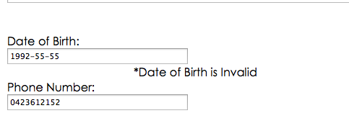

**Outcome**: Success

**Test scenario**: Attempt to create a new employee with empty fields.

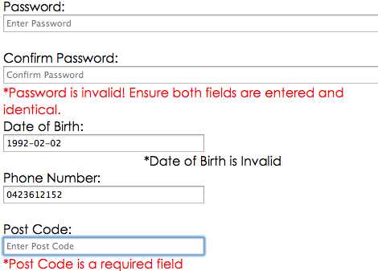

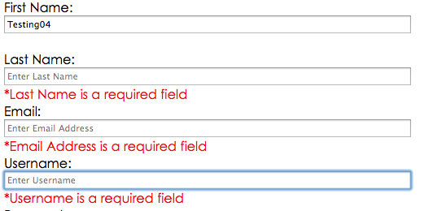

**Outcome**: Success, doesn’t create employee

**Test scenario**: Attempt to edit employee account to have invalid DOB.

Set DOB to invalid date:

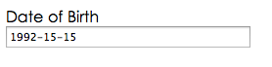

Invalid date is saved successfully:

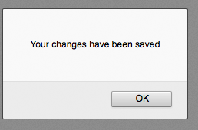

DOB is reset to 0000-00-00:

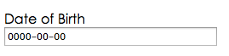

**Outcome**: Semi-success, did not save invalid date. Fix in next release to display error message for invalid dates.

**Test scenario**: Attempt to edit employee details with empty fields.

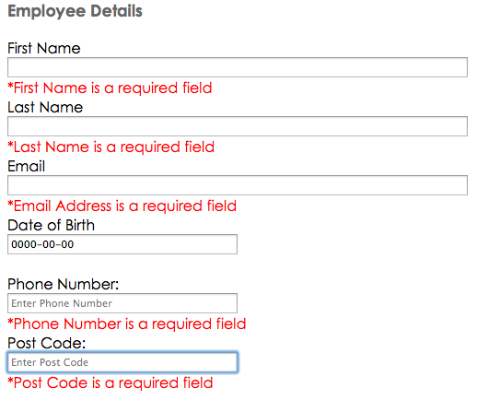

**Outcome**: Success

**Test scenario**: Use new employee account to log in.

Create new employee account:

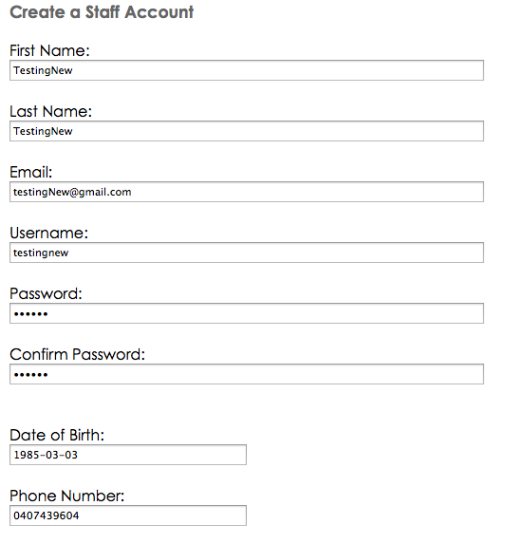

Sign in using new account:

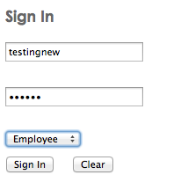

Account sign in successful:

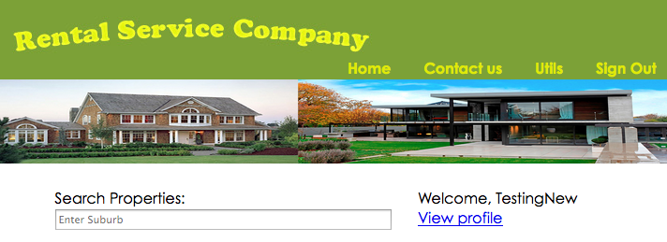

All employee functions available:

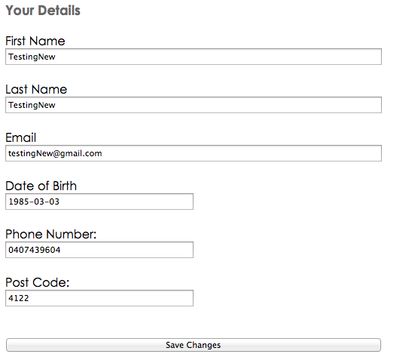

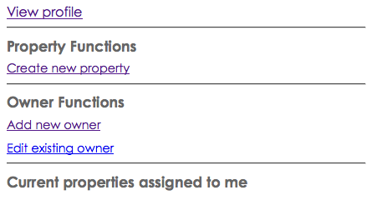

**Outcome**: Success